
Parish Office
Village Hall
Horton Road
South Darenth, Kent
DA4 9AZ
01322 865193
office@hksdparishcouncil.co.uk

Thank you for your enquiry regarding hiring one of our halls. Please note that provisional bookings are held for 7 days (from the date of enquiry). If bookings are within 1 month, the time frame to return the deposit and paperwork is 48 hours.

The Balance Payment is required 4 weeks before your event.

With effect from 01 January 2023, damage deposits for all bookings are £300. This amount is taken as a ‘pre-authorisation’ from your card, preferably a credit card, when you collect the keys on the Friday before your event. Funds of £300 must be available in your account, but it won’t be deducted, similar to when hotels take your card details at check-in. The Damage Deposit pre-authorisation will be cancelled in full on the Monday after your event unless there is a breach of the terms & conditions.

PLEASE NOTE THAT VIEWINGS ARE BY APPOINTMENT ONLY DUE TO THE HALLS BEING IN HIGH DEMAND. More than 1 viewing will attract a fee.

To secure your booking, please return the following to the Parish Office:

- Signed/completed hiring form
- Signed Terms & Conditions
- Booking deposit of either £20 or 25% of the total hire fee, whichever is the greatest.
The preferred method of payment is via BACS (bank details attached). You can also pay by cheque (payable to ‘HKSDPC’) or card in the Parish Office (office hours Tuesdays and Fridays only 9am-12.30pm).

IT IS YOUR RESPONSIBILITY TO ENSURE THE DEPOSIT AND BALANCE ARE PAID ON TIME. FAILURE TO DO SO MAY RESULT IN YOUR BOOKING BEING CANCELLED.

Both the Village Hall and Jubilee Hall exist for the benefit of our local community; we are proud of them and as such we are anxious to take good care of them. We ask all hirers to respect this ethos and therefore have a careful booking procedure including clear Terms & Conditions. Due to maintenance work/hall cleaning or other hirers booking the halls (either before or after your hire), please do not enter the hall(s) early or overrun your hire time.

I look forward to receiving your completed booking forms/deposit at your earliest convenience.

Yours sincerely
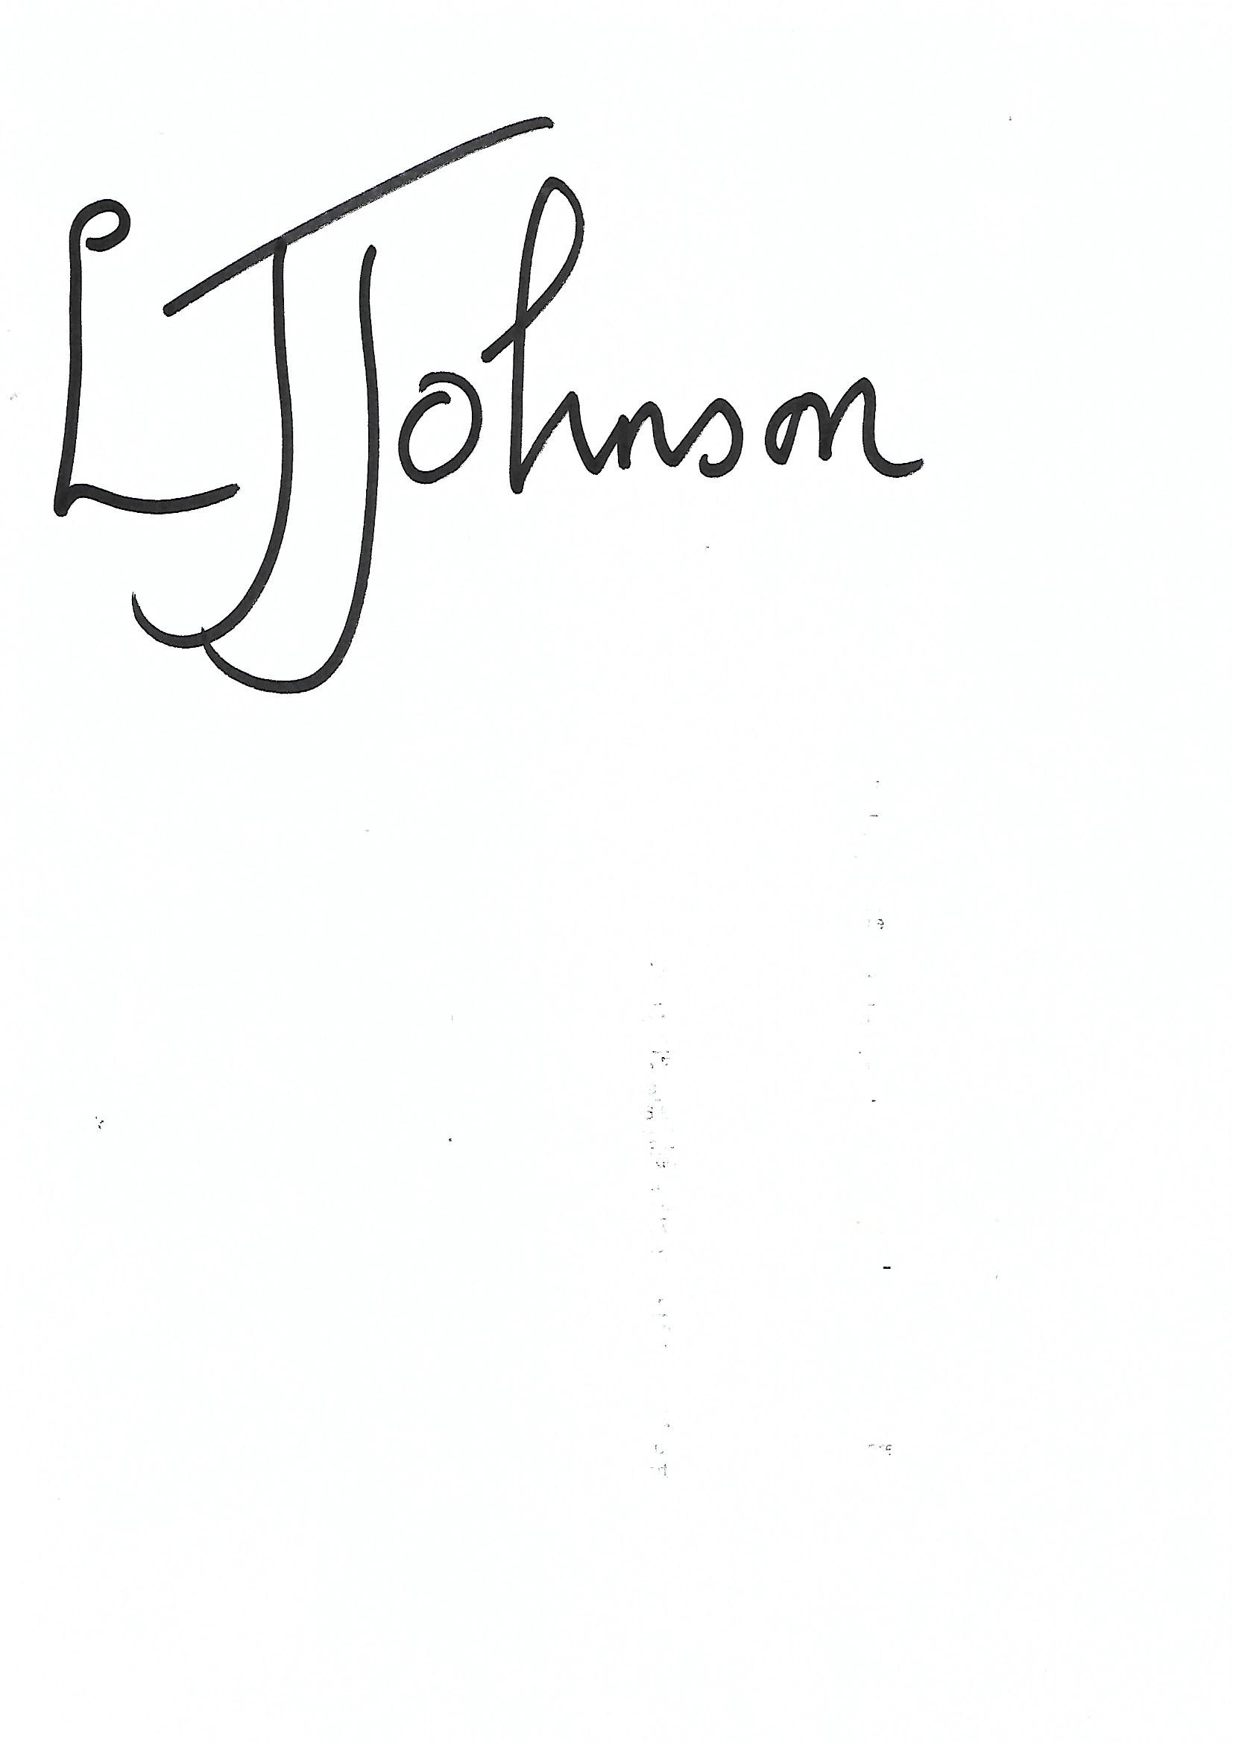
Lisa Johnson
Clerk to the Council

