HORTON KIRBY AND SOUTH DARENTH PARISH COUNCIL
Parish Office, Village Hall, Horton Road, South Darenth DA4 9AX

15th November 2023

TO ALL MEMBERS OF THE HALLS COMMITTEE

A G E N D A

You are summoned to attend a meeting of the Halls Committee to be held on Tuesday 21st November 2023 in the Parish Room South Darenth at 7.30 pm. For members of the public who wish to attend, space is strictly limited for the Parish Room. You must contact the Parish office to book your place in advance by midday on 21st November otherwise you may not be able to attend.

1 APOLOGIES FOR ABSENCE
To receive apologies for absence

2 DECLARATIONS OF INTEREST
To receive apologies for absence

3 MINUTES
To confirm the Minutes of the last meeting, September 2023.

4 MATTERS ARISING
Items arising from the Minutes of the last meeting (for information only unless specified in advance and included on this agenda)

5 QUESTIONS FROM THE PUBLIC and CORRESPONDENCE
To allow 10 minutes for members of the public to raise any matters for consideration or read out any correspondence received. Items that are not the responsibility of the Halls Committee will be informed of the relevant committee, parish council or authority to direct their query to.

6 PRIVATE HIRERS
To receive summary of feedback forms 01 April – 31 October 2023

7 FINANCE
To receive latest budget report and review.

8 MAINTENANCE
To receive updated report, decide actions and set deadlines.

The chair will then resolve to exclude press & public by reason of the confidential nature of the business to be transacted from the meeting under HK & SD Parish Council’s Standing Order 3(d) and 11(a) Disclosure of such would breach the obligations of a Council under the Data Protection Act 1998.

9 CONFIDENTIAL ITEM
To consider Village hall security.

10 CONFIDENTIAL ITEM
To discuss Regular hirer.

11 DATE OF NEXT COMMITTEE
Tuesday 16th January 2024.

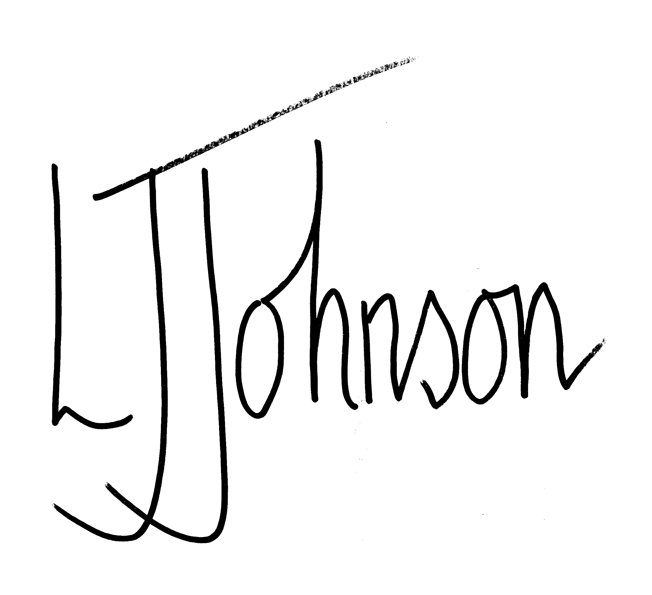
Lisa Johnson, Clerk to the Council

